**Section 3.8 Geodetic Measurements**

**Reference**

Global Positioning System Overview, Peter H. Dana, Department of Geography, University of Texas

at Austin, 1994. ([www.colorado.edu/geography/gcraft/notes/gps/gps_f.html](http://www.colorado.edu/geography/gcraft/notes/gps/gps_f.html))

Charles D Ghilani, Penn State College of Engineering, 2008 (http://surveying.wb.psu.edu/sur351/georef/Ellip4.htm)

**Acronyms, Abbreviations and Symbols**

DGPS Differential Global Positioning System

ECEF Earth Centered Earth Fixed coordinate system

GPS Global Positioning System

INS Inertial Navigation System

WGS84 World Geodetic System 1984

*a* Earth’s semi-major axis radius

*b* Earth’s semi-minor axis radius

*D* Great circle distance between two points

*e* eccentricity of the Earth square

*f* Earth’s flatness factor

*h* geodetic height

*N* radius of curvature in prime vertical

*P* radius of curvature in prime vertical

$\overset{→}{P}$ Vector from earth center extending to coordinates

*r* Earth’s radius

*X* ECEF x coordinate

*Y* ECEF y coordinate

*Z* ECEF z coordinate

 Geodetic latitude

 Angle between the two $\overset{→}{P}$ vectors originating at the Earth’s center and extending to their respective coordinates at the start and end points.

● Geodetic longitude

 Runway heading with respect to true North.

**Earth Modeling**

The Geodetic System (i.e. latitude, longitude and height) commonly defines the location of any point relative to the earth (Figure 3.8-1, point P). Longitude and latitude are expressed in degrees, minutes, seconds. Longitude lines extend $±$ 180 degrees from the Prime Meridian, run north to south, and converge at the poles. Latitude lines are parallel to the equator and extend $±$ 90°.

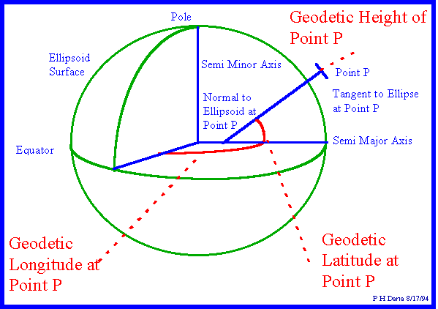

**Figure 3.8-1 Geodetic Coordinate System**

The 1984 world geodetic system, WGS84, models the earth’s surface as an oblate spheroid - an ellipsoid rotated about its semi-minor axis. In this model (used by GPS systems), the earth’s semi-major axis, *a* is 6,378,137.0 meters and the semi-minor axis, *b* is 6,356,752.314 meters.

The flatness factor (*f*) is defined as:

$$f=\frac{a-b}{a}$$

For the WGS84 model, *f* =1/298.257223563

Any plane passing through the center of a spheroid traces a great circle around the perimeter of that spheroid. The shortest distance between two points on the surface is that portion of the great circle arc encompassing both points (Figure 3.8-2).



**Figure 3.8-2 Great Circle Arc**

Note: navigating along a great circle route has the disadvantage of not intercepting longitude lines at the same angle (except when flying along the equator); in other words, the heading changes along the route.

For the purpose of performance, navigation, or noise analysis, flight testers may require distances between two points (the shortest being along the great circle arc) and the average heading of that arc. Calculating these from typical Geodetic System Lat/Long inputs requires conversion to the Earth Centered Earth Fixed (ECEF) coordinate system as shown in Figure 3.8-3.



**Figure 3.8-3 Earth Centered Earth Fixed Coordinate System**

The ECEF coordinate system is a Cartesian system with the origin at the earth’s center. In this system, the X-axis is defined by the intersection of the Prime Meridian and equatorial planes. The Z-axis goes through the North Pole. The Y-axis completes a right-handed orthogonal system by a plane 90 degrees east of the X-axis and its intersection with the equator. Geodetic System (lat/long/height) data converts to ECEF as follows:

*x* = (*N* + *h*)cos()cos()

*y* = (*N* + *h*)cos()sin()

*z* = (*N*(*1-e2*)+ *h*) sin()

where,

*x* = ECEF coordinate parallel to the X-axis

*y* = ECEF coordinate parallel to the Y-axis

*z* = ECEF coordinate parallel to the Z-axis

** = geodetic latitude

** = geodetic longitude

*h* = height above geodetic surface

*N* = Normal radius; distance from earth center to any point on the modeled surface at that latitude

$$N=\frac{a}{\sqrt{1-e^{2}∙\sin^{2}(ϕ)}}$$

where,

*a* = semi-major axis radius

*e2* = eccentricity squared; $e^{2}=1-{\left(\frac{a}{b}\right)}^{2}=2∙f-f^{2}$ = 0.00669438002290 (Earth, per WGS84)

.

**Great Circle Distance**

The great circle distance (D) between points (subscripts 1 and 2) can be calculated as

$P_{1}=\sqrt{x_{1}^{2}+y_{1}^{2}+z_{1}^{2}}$, ${ P}_{2}=\sqrt{x_{2}^{2}+y_{2}^{2}+z_{2}^{2}}$

$${\overset{→}{P}}_{1}∙{\overset{→}{P}}_{2}=P_{1}∙P_{2}\cos{φ}=x_{1}∙x_{2}+y_{1}∙y_{2}+z_{1}∙z_{2}$$

$$φ=arccos\left(\frac{x_{1}∙x_{2}+y_{1}∙y_{2}+z_{1}∙{Zz}_{2}}{P_{1}∙P_{2}}\right)$$

$$D=N(ϕ_{avg})∙φ$$

where

*P* = distance from earth center to any point (including height above the spheroid surface).

$\overset{→}{P}$ = Vector from the Earth’s center to point P.

 = Angle between the two  vectors

* avg*) = Normal radius using average latitude of points 1 and 2

For shorter distances typical of local flight testing, the Great Circle model approximates a two

dimensional model.

Distance North-South (Northing): *dy* = *N*() sin()

Earth’s radius East-West: *r* = *N*()cos()

Distance East-West (Easting): *dx* = *r* sin()

Distance between two points: $D=\sqrt{dx^{2}+dy^{2}}$

Heading between two points (relative to true north)  = arctan(*dy/dx*)

**Runway Distance Transformation**

Data from a runway survey provides a reference point for determining the distance to key locations (e.g. brake release, liftoff, microphone array). From runway survey data, a local coordinate system can be established that uses any point on the runway as the origin, and can either

1. keep the same X, Y and Z axes or
2. set height as the Z-axis, direction along the runway heading as the X-axis, and direction normal to the runway centerline as the Y-axis (Figure 3.8-4).

**Figure 3.8-4 Local Coordinate System**

For the second option above, distance along and normal to the runway can be calculated using the following geometry definitions and equations (Figures 3.8-5 and 3.8-6):

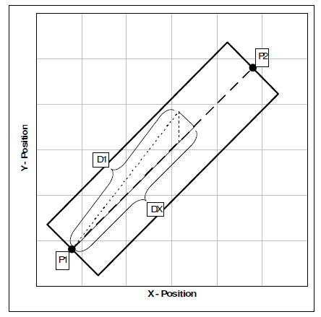

**Figure 3.8-5 Local Geometry 1**

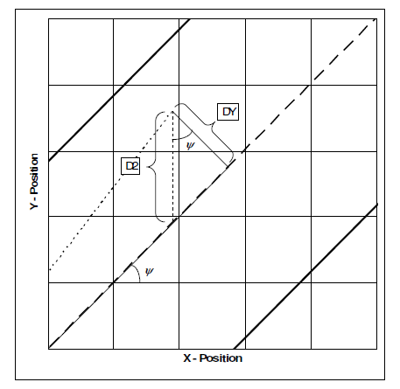

**Figure 3.8-6 Local Geometry 2**

P1= Main reference point along runway centerline (subscript 1 in the following equations)

P2= 2nd point defining runway centerline (subscript 2 in the following equations)

 = runway centerline heading with respect to true north.

*D*1 = total distance from reference point to current position.

*D*2 = distance from current position to runway along the same X position (i.a.w. ECEF coordinates)

*DX* = distance along runway centerline from reference point to current position.

*DY* = normal distance between runway centerline and current position.

*m* = slope of runway centerline equation.

*b* = intercept of runway centerline equation.

$$ψ=arctan\left(\frac{y_{2}-y_{1}}{x_{2}{-x}_{1}}\right)$$

$$D1=\sqrt{{\left(x-x_{1}\right)}^{2}+{\left(y-y_{1}\right)}^{2}}$$

*y = mx +b*, $m=\frac{y_{2}-y_{1}}{x_{2}-x_{1}}$, $b=\frac{x_{2}∙y_{1}-x_{1}{∙y}_{2}}{x_{2}-x_{1}}$

$$\cos{ψ=\frac{DY}{D2}=\frac{DY}{y-(mx+b)}}=\frac{x_{2}-x_{1}}{\sqrt{{\left(x_{2}-x_{1}\right)}^{2}{+\left(y_{2}{-y}_{1}\right)}^{2}}}=\frac{1}{\sqrt{m^{2}+1}}$$

$$DY=\frac{\left|y-mx-b\right|}{\sqrt{m^{2}+1}}$$

$$DX=\sqrt{{D1}^{2}-{DY}^{2}}$$

Note: the above heading equation applies between any two points and may be useful for navigation analysis in a local environment.